**Raj Singh: COSC 4353 Software Design**

**Group 10 - Assignment 2**

**GROUP 10: Satya Sai Sribhashyam,Tasneem Patel, Jenish Bhadola**

1. **Provide link to GitHub repository for TAs to view the code? (1 point)**

Link to our Github repository:

<https://github.com/Jnbhadol/Project_Group10.git>

1. **Discuss if your design and development methodology has changed since assignment 1 and why? (1 point)**

For the most part of our building process, we have not changed much of our process/methodology and design from the first assignment. We managed to build our front end for our website with only html and css. We made a centralized css file which contained the code for all the background settings, text, color, font, and font sizes, for all of the html pages we have designed. We have also put validations in the required fields as mentioned (by the client) for the profile and fuel quote form pages. We also included the field types in the pages, that tell how the data in the fields is going to be stored (following the client requirements). Also, the website pages that we made are good to use with any type of device (mobile phones, computers, tablets, etc).

1. **List what front end technologies you are using and why. List who is responsible of doing what in your group? (2 points)**

We have used about the same tools we have mentioned in the first assignment. We used tools such as HTML and CSS for building our front end pages, because these tools are easy and widely used for making responsive and good looking web pages. We have also used compiler tools such as Visual Studio Code and Windows Notepad for the front end codes.

1. **Provide screenshots of your front end, each page? (5 points)**

Client Login page:

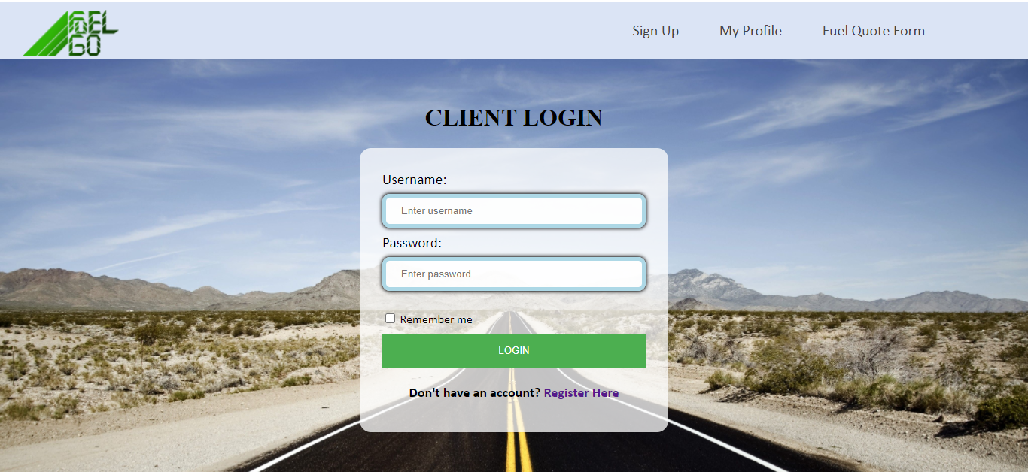

Client Registration page:

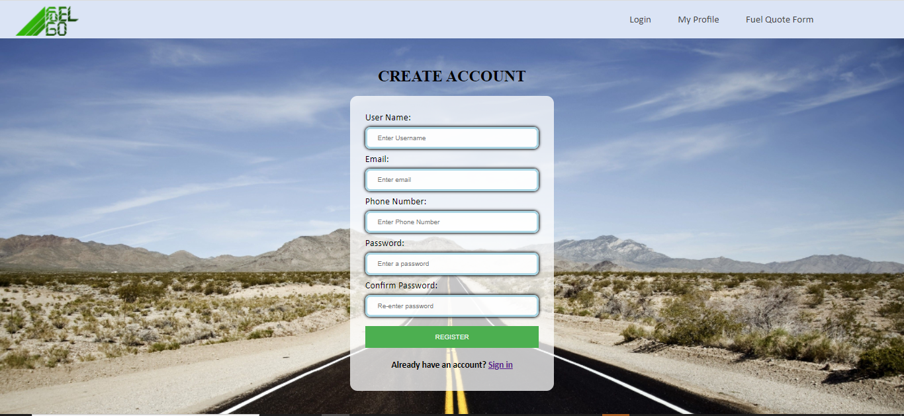

Client Profile Management page:

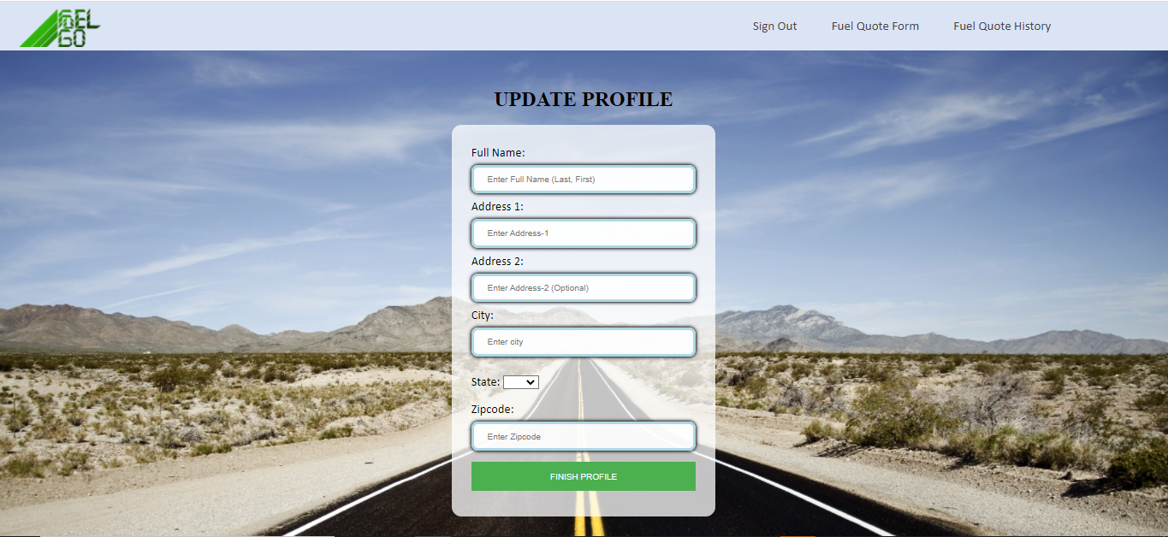

Fuel Quote Form page:

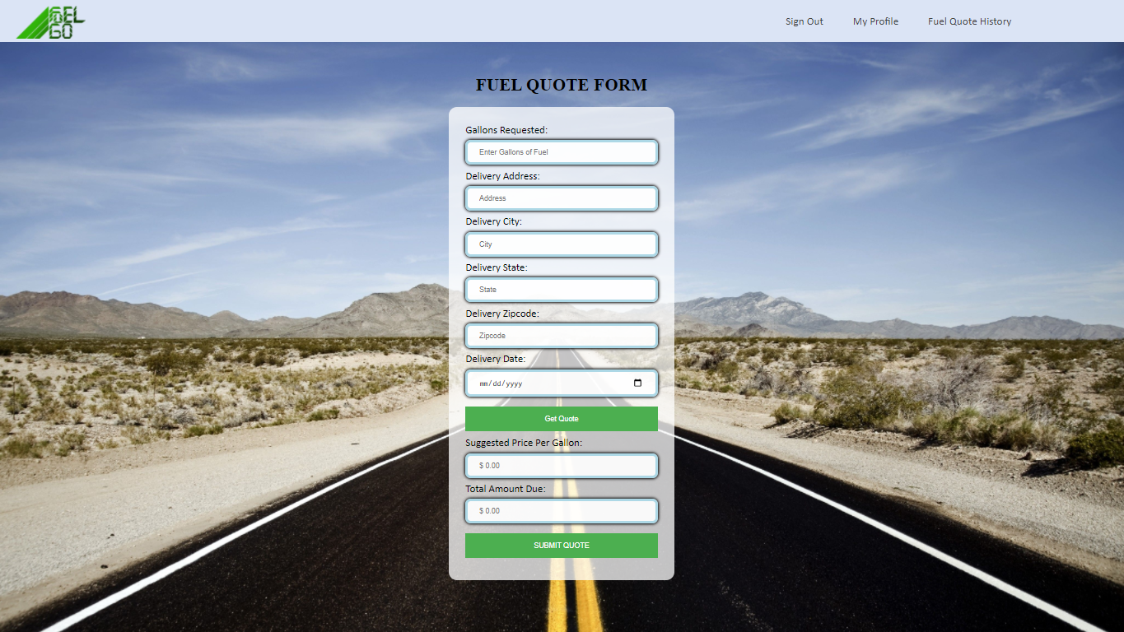

Fuel Quote History page:

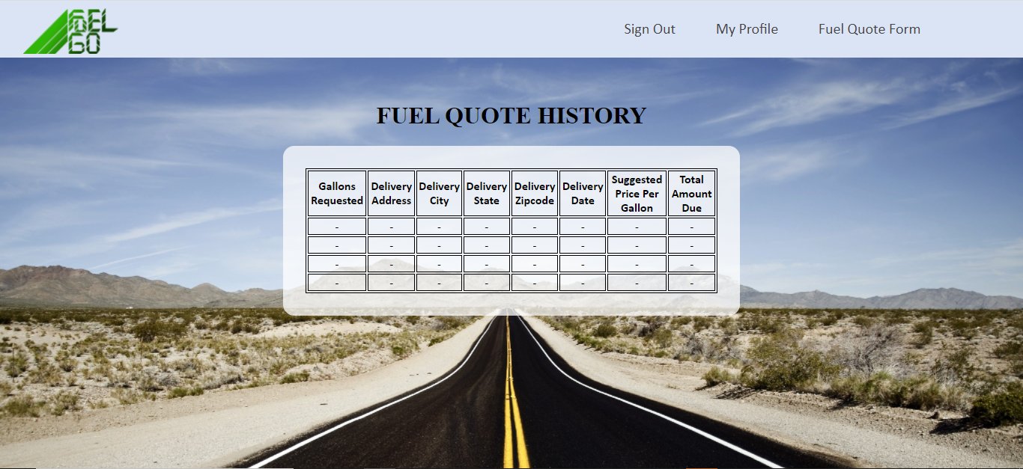

1. **IMPORTANT: list who did what within the group. TAs should be able to validate in GitHub, otherwise team members who didn't contribute will receive a ZERO. (1 point)**

Fill in this table, provide as much details possible:

| Group Member Name | What is your contribution? | Discussion Notes |
| --- | --- | --- |
| Tasneem Patel | CSS and HTML pages | Worked on CSS styling and HTML pages for client login, registration, profile, along with creating and styling the navigation bar |
| Satya Sai Sribhashyam | CSS, debugging/quality testing, fixing HTML codes | Worked on CSS styling, fixed codes for login page and registration, debugging/quality testing, documentation |
| Jenish Bhadola | CSS file and HTML pages, Title logo | Worked on CSS styling and HTML pages for Fuel quote and quote history pages. Also worked on the website logo design |